2020

**Submitted By:**

**Iqbal Singh**

Project Report



**Contents**

Project Proposal 2

Goals and Objectives 2

Scope and Deliverables 2

Project Scope 2

Project Deliverables 2

Project Specification and Target Audience 2

Project Schedule and milestones 3

Resources Required 3

Functional and Non-Functional Requirement 3

Functional Requirements 4

Non-Functional Requirements 4

Project Assumptions 4

Detailed Design 4

Home Page 4

Login Page 4

Company Sign-up Page 5

Company Deals Page 5

Company Details Page 6

Customer Sign-up Page 6

Customer Details Page 7

Customer Deals Page 8

Project Testing 8

User Manual 8

Customer Activities 9

Company Activities 9

# Project Proposal

## Goals and Objectives

Post Deal is an online application where companies can post best deals for low prices. This application is implemented using ASP.Net. with the help of this application customers can see deals from a wide range of companies. In this application there are two types of users companies and customers. Companies hold admin rights in the application while, customers are having normal rights. Companies can edit, delete and access details of their profiles. Companies can also add new deals, edit and delete existing ones. Companies can register new company as admin for the application. New customer can sign-up for the application. Customer can edit and delete their profiles. Moreover, customer can only view deals from various companies.

## Scope and Deliverables

## Project Scope

The duration for the project was 4 weeks i.e 20 days approximately. The scope of the project is to implement the admin functionality such as add, edit, delete. For customer to implement the functionality of edit, delete for their accounts and to view the deals. Also, to test the usability of the application.

## Project Deliverables

To achieve the goal of our project, we have set following deliverables:

|  |  |
| --- | --- |
| **Deliverables** | **Explanation** |
| Project Planning | It includes project scheduling and design. |
| Design | It includes the front end design for the web application |
| Coding | This includes the coding part of the project. |
| Implemetation and Testing | This will demonstrate how application it will be used and also the test details of the wev app. |
| Final Documentation | It includes the final documentation for the project.. |

## Project Specification and Target Audience

* Login and logout should be secure for both company and customer.
* Add, edit, delete deals by companies.
* Edit, delete and access details of the company details by admin company.
* Customer can edit and delete their accounts
* Customers can view deals on the application.

Moreover, the Target audience for this web application will be the people who are willing to save money by grabbing best deals for food, clothes, furniture etc. Age group is 10 plus and can go upto 100 or more.

# Project Schedule and milestones

|  |  |  |
| --- | --- | --- |
| Phases/ Milestones | Time Frame in Weeks | Deliverable(s) Completed |
| Project Scheduling | 1-2 | * Commencement Meeting * Project Explanation Document * Requirement Analysis Report * Project Proposal |
| Stage 1 | 2-3 | * Designing of Database * Front End Design |
| Stage 2 | 3-4 | * Front End implemetation * Back End Implementation * Final App |
| Stage 3 | 3-4 | * Testing * Final Documentation and Report Writing |

# Resources Required

Following are the resources required to complete this project:

* MS Word, Excel
* ASP.Net MVC and Identity Framework
* Windows OS 10
* Minimum i5 processor with 4-8 GB of RAM

# Functional and Non-Functional Requirement

The functional and non functional requirements for the project are as below:

## Functional Requirements

* Application should allow new customer to register.
* Existing companies and customers can login and view the available deals.
* Companies can manage the deals and manage deals by editing and deleting.
* Admin company can add new admin and can manage the existing ones.
* Customers can edit and delete their accounts and can view deals.

## Non-Functional Requirements

* Loading speed of the application should be fast.
* Multiple browser and device support
* Accessability and usability of the application..

## Project Assumptions

Following are the assumetion which I made while developing this project:

* The availbity of user has been considered as avilable all time for feedback.
* Minimum One company will be registered as admin with the application.
* One customer will be registered with the application by default.

# Detailed Design

## Home Page

This is main page of the web application. All user can view this page of the application even without login. This page contain home, deals, customer Sign up, company sign-up and Login menu options on the navigation bar.

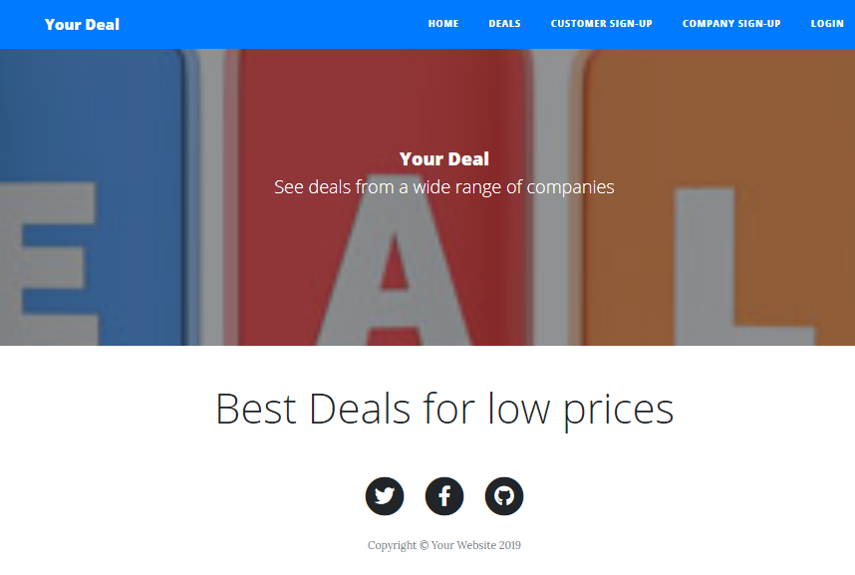

## Login Page

This Page of the application will be used by company and customer to login into the system.

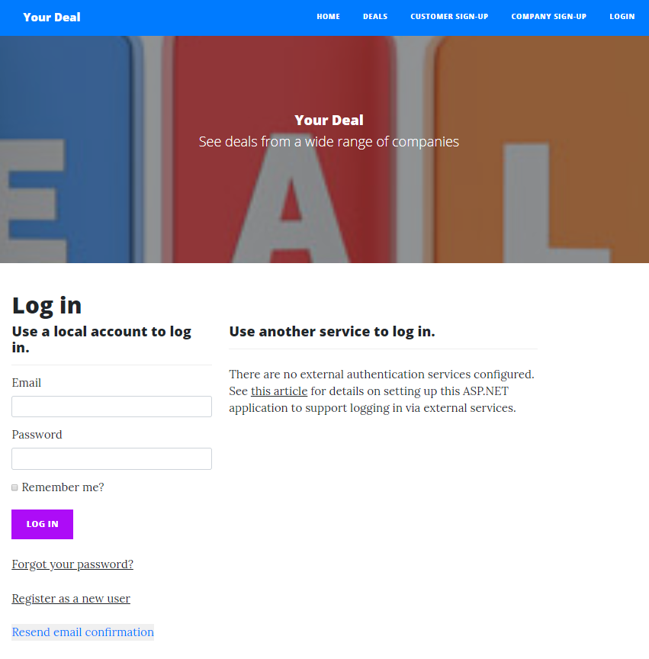

## Company Sign-up Page

With the help of this page new company can signup for the application.

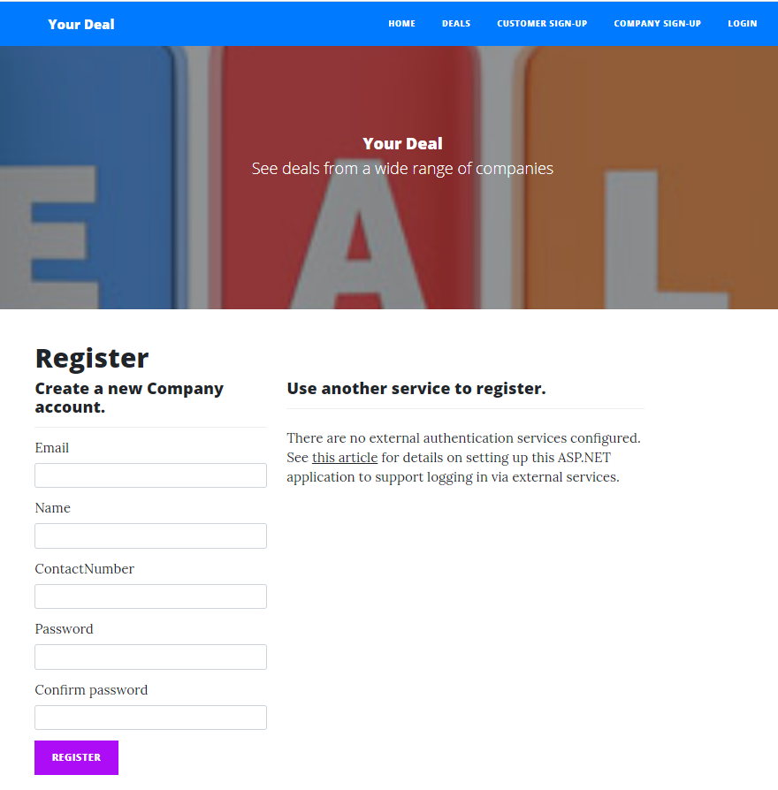

## Company Deals Page

With the help of this page companies can add new deals and edit and delete the existing deals.

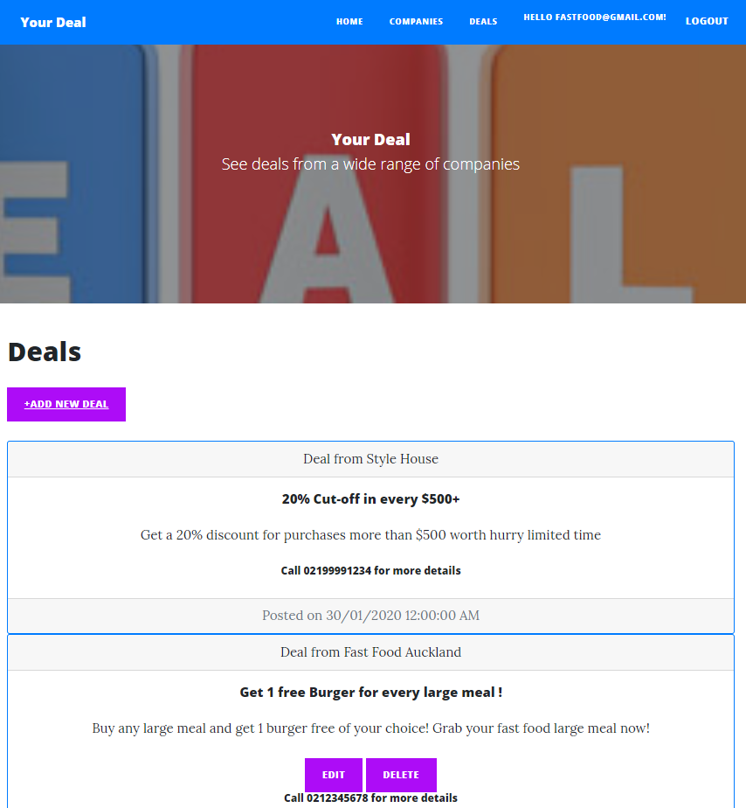

## Company Details Page

In this page admin can edit,delete and view details of their accounts.

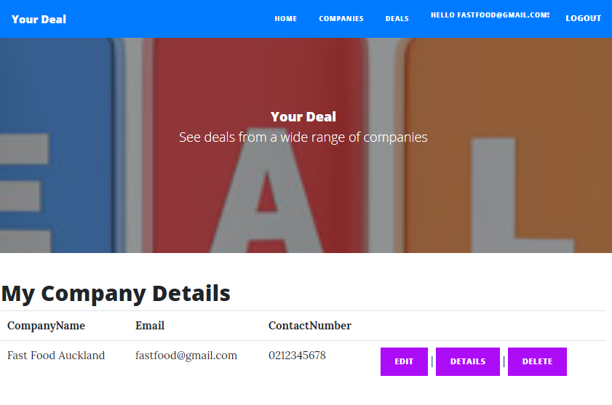

## Customer Sign-up Page

With the help of this page, new customers can register themselves with the application.

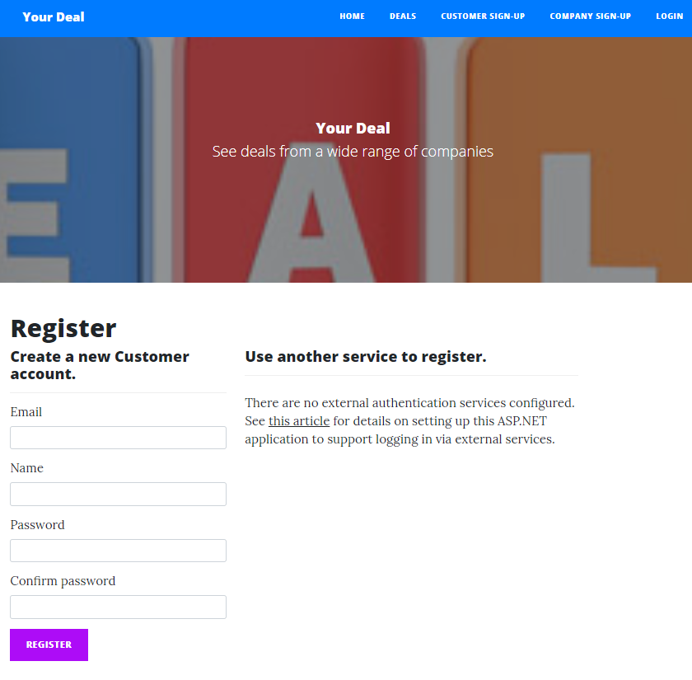

## Customer Details Page

With the help of this page customer can edit and access details of their aacount.

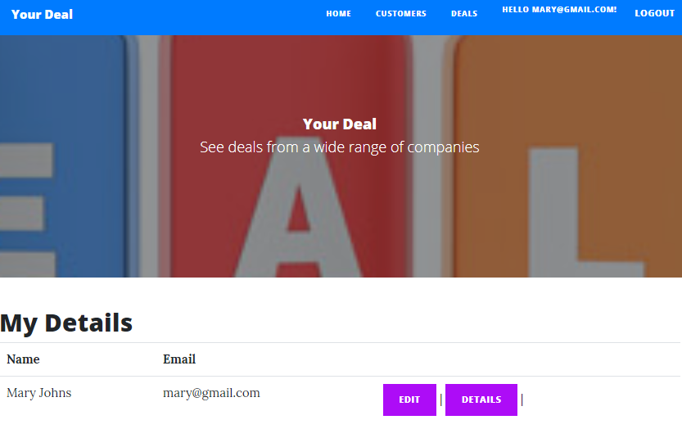

## Customer Deals Page

With the help of this page customers can view deals provided by various companies.

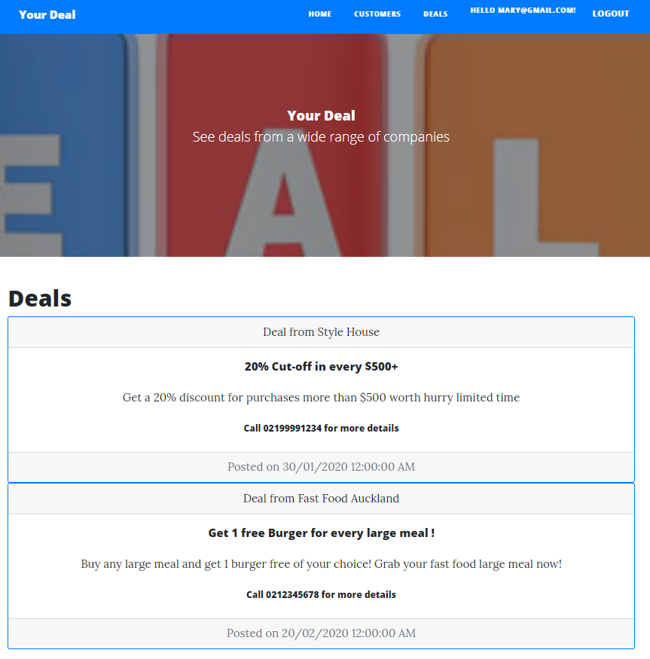

# Project Testing

Due to the limited time for the project, only main features of the web application are tested. Here I have tested the desktop version only. This report includes the accessibility, functionality, usability testing. There will be testing for navigation and performance as well. Testing is performed on Windows 10 Operating system, 64 bit i5 processor, 8 GB RAM and Google chrome web browser. Testing has the following Pass/Fail criteria:

* Completion of all test cases.
* Working of the main functionality
* Test competion percentage without errors

Usability testing of the application can be found at [Usability Testing.xls](Usability%20Testing.xls)

# User Manual

Post Deal is an online application where companies can post best deals for low prices. This application is implemented using ASP.Net. with the help of this application customers can see deals from a wide range of companies. In this application there are two types of users companies and customers. Companies hold admin rights in the application while, customers are having normal rights. Companies can edit, delete and access details of their profiles. Companies can also add new deals, edit and delete existing ones. Companies can register new company as admin for the application. New customer can sign-up for the application. Customer can edit and delete their profiles. Moreover, customer can only view deals from various companies.

## Customer Activities

* New Customer Registeration
* Login/Logout
* View Deals
* Manage their accounts.

## Company Activities

* New company Admin registration.
* Login/Logout
* Add, edit, delete, deals.
* Edit, delete and access details of companies.